**Data feed enhancements and MYMI changes**

**for Project Robin**

**Business Requirements Document**

**Version:** 0.6

**Date:** 23/06/2022

**Author:** Ruparekha Singh

**Technical Reviewer:** Graham Binner and Rishi Gupta

# Document Control

| **Version** | **Dated** | **Author** | **Reason for revision** |
| --- | --- | --- | --- |
| 0.1 | 10/03/2022 | Ruparekha Singh | Draft |
| 0.2 | 14/03/2022 | Ruparekha Singh | Incorporated inputs from Paul, Rishi and Tim. |
| 0.3 | 26/04/2022 | Ruparekha Singh | Updated Requirement 5.6 & 5.7 |
| 0.4 | 17/05/2022 | Ruparekha Singh | Included detailed MYMI requirements and updated acceptance criteria for all requirements. |
| 0.5 | 17/06/2022 | Ruparekha Singh | Included new requirements for Robin Switch, Exception for Engineering & CPE Class |
| 0.6 | 23/06/2022 | Ruparekha Singh | Updated details based on inputs from Rishi & Tim. |

# Key Reviewers

| **Reviewer** | **Role** | **Sign Off Date** |
| --- | --- | --- |
| Rishi Gupta | BI Architect/ Lead Consultant |  |
| Graham Binner | Data and Reporting Architect |  |
| Paul Metson | Head of Outwards Reinsurance Operations |  |
| Andrew Stallan | Senior Data Quality Analyst |  |
| Paul Crosby | Riverstone- Business Analyst |  |
| Gursel Kais | Riverstone- Developer and Key Data Reviewer |  |
| Colin Smart | Riverstone- Delivery Lead |  |

Contents

Document Control 2

Key Reviewers 3

1 Introduction 5

1.1 Purpose 5

1.2 Background 5

2 Current State 6

3 Future State 9

4 Scope 10

4.1 In Scope 10

4.2 Out of Scope 10

4.3 Assumptions 10

5 Requirements 11

5.1 Modify Riverstone View to provide AS-AT data 11

5.2 Remove Temporary Adjustments 12

5.3 Remove Claim_ID from Outward Fact 13

5.4 Modify Risk_ID of Outward Fact 13

5.5 Remove Outward Written Premium Fact 14

5.6 Distinguish between Robin and Legatum transaction in feed 14

5.7 Indicator for reconciliation between control and extract data sets 15

5.8 Frequency of Data feed 15

5.9 MYMI Indicator for Robin Inward and Outward Transaction 17

5.10 Exclude ORI Contract Ref from Outward Fact 18

Annexure 21

BA Testing Strategy 21

Legatum Feed Specification 21

High level Requirements V 0.5 21

Technical Solution Specification 22

Impact Assessment Document 22

# Introduction

## Purpose

This document captures the high-level MYMI changes and data feed enhancements for RITC Legatum and RITC Robin including:

1. Introduction to MYMI Partitions.
2. Introduction to Adjustments in MYMI.
3. Definition of Legatum and Robin flag.

The detailed data analysis is captured in the Devops. Any changes to requirements or acceptance criteria would be updated in this document. This is a live document until the sections of the document which are highlighted as “TBD” are confirmed.

The technical specification for the current feed and technical solution document are appended to the annexure and should be read in conjunction with this document.

## Background

Riverstone Managing Agency Limited (RSMA) and Brit Syndicates Limited (BSL) entered a loss portfolio transfer (LPT) whereby RSMA reinsures BSL in respect of its liabilities under certain policies as defined in the LPT agreement.

The first transaction was concluded under project Legatum in November 2018. As part of the project, a daily data feed was developed to provide Riverstone with inwards and outwards premiums and claims movements. The second transaction, Project Robin, of similar nature and with a different data selection criterion was concluded in October 2021. This required an enhancement of the existing data feed to:

* Include the Classes of Business included in RITC Robin.
* Improve the current data feed to reduce the daily or monthly maintenance activities.

# Current State

After the daily MYMI load is completed, the data feed is triggered automatically daily to provide Inward data to Riverstone. The Outward data is triggered manually after the monthly financial close process is completed in MYMI. Both the data sets use latest calendar partition from MYMI.

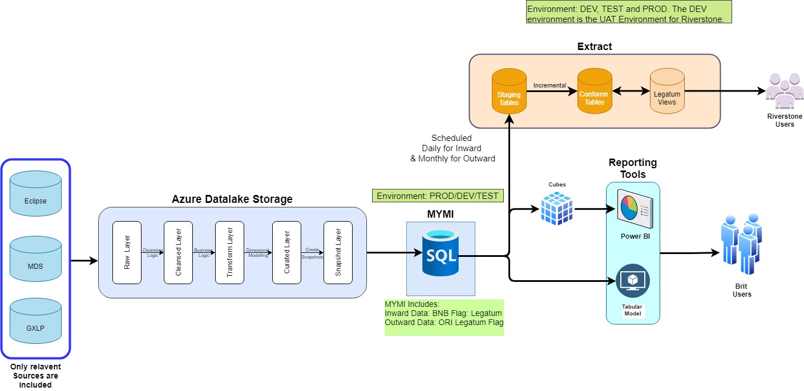

***Diagram 1: Current Data Flow***

The extract has two steps:

1. Staging tables: These tables hold the latest Inward and outward data from MYMI. The data is held in a dimensional data model. Following are the list of tables in extract. These tables are truncated and loaded for each data load.

|  |  |  |  |
| --- | --- | --- | --- |
| Key | Definition | Inward/Outward | Tables |
| 1 | Dimension | Inward | INW_Group_Class |
| 2 | Dimension | Inward | INW_Loss |
| 3 | Dimension | Inward | INW_Loss_Event |
| 4 | Dimension | Inward | INW_RISK |
| 5 | Fact | Inward | inw_control_os_claim |
| 6 | Fact | Inward | INW_OS_Claim_Extract |
| 7 | Fact | Inward | inw_paid_claim_control |
| 8 | Fact | Inward | inw_paid_claim_extract |
| 9 | Fact | Inward | INW_Premium_Control |
| 10 | Fact | Inward | INW_Premium_Extract |
| 11 | Fact | Inward | INW_Written_Premium_Control |
| 12 | Fact | Inward | INW_Written_Premium_Extract |
| 13 | Dimension | Outward | OUTW_Group_Class |
| 14 | Dimension | Outward | OUTW_Loss |
| 15 | Dimension | Outward | OUTW_Loss_Event |
| 16 | Dimension | Outward | OUTW_RI_Contract |
| 17 | Dimension | Outward | OUTW_RI_Contract_Acc |
| 18 | Dimension | Outward | OUTW_RI_Contract_Ccy_Limit |
| 19 | Dimension | Outward | OUTW_RI_Contract_Ins |
| 20 | Dimension | Outward | OUTW_Risk |
| 21 | Fact | Outward | OUTW_Control_OS_Claim |
| 22 | Fact | Outward | OUTW_Control_OS_Premium |
| 23 | Fact | Outward | OUTW_Control_Paid_Claim |
| 24 | Fact | Outward | OUTW_Control_Paid_Premium |
| 25 | Fact | Outward | OUTW_OS_Claim_Extract |
| 26 | Fact | Outward | OUTW_OS_Premium_Extract |
| 27 | Fact | Outward | OUTW_Paid_Claim_Extract |
| 28 | Fact | Outward | OUTW_Written_Premium_Control |
| 29 | Fact | Outward | OUTW_Written_Premium_Extract |

*Table 1: List of Tables in Extract*

1. Conform Tables: The incremental data based on data in Staging table and conform table is derived and loaded to conform table using the latest valid_to_date. The derivation logic is captured in conform stored procedure applicable for each Fact and dimension table. These procedures have anomalies and does not always meet the requirements. Due to which the incremental transaction in Control and extract tables go out of sync and requires frequent data fixes to align the extract and control tables.

**Known Operational Issues**

Following are some of the operational issues recognised by Riverstone.

|  |  |  |
| --- | --- | --- |
| No | Issue | Summary |
| 1 | Missing Lloyds Risk code | There are claims coming through in the data feed which do not have a Lloyds risk code. When we look at the weekly movement spreadsheets supplied by Brit Claims department, these same claims do have a Lloyds risk code. We believe these are the Broadspire claims processed by Crawford. |
| 2 | Outward premium records sent each day despite no changes | We’ve noticed that we started to receive outwards data (OUTW_OS_CLAIM_EXTRACT) every other day since 20-Dec-2021. And they are not actual movements, just replacing an old movement with same amount ($0). |
| 3 | Replacement movements not working correctly | Replacement movements are not working properly. When this occurs, Harshith performs a data fix. Ideally, we should resolve the underlying cause. Issue occurred 4th Feb and data fix performed by Srinath Reddy. |
| 4 | Automated controls | We run controls on our side to ensure the integrity of the data – these effectively compare the transaction data supplied against the control data supplied. We would like these automated on the Brit side, then a flag set informing us that the daily update is complete and controlled. We will only load data on our side if this flag is set. This will ensure we cater for scenarios where the data feed over runs or a data integrity error has occurred. |
| 5 | Adjusted Policies | MyMI contains adjustment policies (for example SELECT * FROM inw_os_claim_extract P WHERE claim_id = -3). These will never be included in the bordereau, therefore can be excluded from the data feed. The volumes of these movements are high. |

*Table 2: Issues Raised by Riverstone Team*

# Future State

The below diagram depicts the high-level data flow. The detailed data requirements are captured in the requirements section.

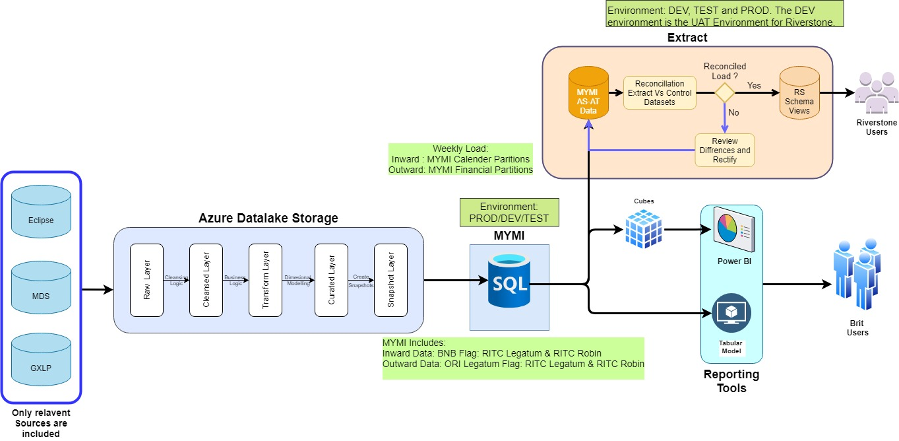

***Diagram 2: Future Data Flow***

# Scope

## In Scope

* To streamline the data feed by replacing the incremental load with AS-AT data along with meeting all data requirement specified in the requirement section.
* Operational Issues in scope for the project is as specified below:

|  |  |  |  |
| --- | --- | --- | --- |
| No | Issue | Description | Detailed |
| 3 | Replacement movements not working correctly | Replacement movements are not working properly. When this occurs, Harshith performs a data fix. Ideally, we should resolve the underlying cause. Issue occurred 4th Feb and data fix performed by Srinath Reddy. | The movements are now replaced by AS-AT transactions. Requirement (1) |
| 4 | Automated controls | We run controls on our side to ensure the integrity of the data – these effectively compare the transaction data supplied against the control data supplied. We would like these automated on the Brit side, then a flag set informing us that the daily update is complete and controlled. We will only load data on our side if this flag is set. This will ensure we cater for scenarios where the data feed over runs or a data integrity error has occurred. | The Control and Extract tables would be reconciled before moving the data to the view. Requirement (7) |
| 5 | Adjusted Policies | MyMI contains adjustment policies (for example SELECT * FROM inw_os_claim_extract P WHERE claim_id = -3). These will never be included in the bordereau, therefore can be excluded from the data feed. The volumes of these movements are high. | Only temporary adjustments would be excluded. Requirement (2). |

## Out of Scope

* Any update to data feed which feeds GXLP from Riverstone.
* Following operational issues are outside the scope of the project:

|  |  |  |  |
| --- | --- | --- | --- |
| No | Issue | Description | Detailed |
| 1 | Missing Lloyds Risk code | There are claims coming through in the data feed which do not have a Lloyds risk code. When we look at the weekly movement spreadsheets supplied by Brit Claims department, these same claims do have a Lloyds risk code. We believe these are the Broadspire claims processed by Crawfords. | This issue is outside the scope of this project and would be dealt as part of future MYMI enhancements. |
| 2 | Outward premium records sent each day despite no changes | We’ve noticed that we started to receive outwards data (OUTW_OS_CLAIM_EXTRACT) every other day since 20-Dec-2021. And they are not actual movements, just replacing an old movement with same amount ($0). | Processing Issue, outside the scope of the project team. |

## Assumptions

|  |  |  |
| --- | --- | --- |
| Assumptions | To be Validated by | Status  (Open/Confirmed) |
| Riverstone’s Operational team would use the AS-AT data to calculate movements to process the transactions. | Gursel Kais | Open |
| Riverstone’s Operational applications can handle the volume of data provisioned. | Gursel Kais | Open |
| The infrastructure, security, and extract process will remain unchanged however there will be minor structural changes likes adding of flag, removing obsolete feeds and replacing a couple of columns in a fact table. | Gursel Kais | Open |

# Requirements

## Modify Riverstone View to provide AS-AT data

|  |  |
| --- | --- |
| Proposed | Phase I |
| User Story | As a data provider, I would like to deliver AS-AT data instead of incremental data to eliminate the requirement of data fixes due to errors in the incremental transactions in conform tables. |
| Deliverables | 1. The Inward and Outward Legatum conform tables and procedures would be removed. 2. The data feed view would read from the new tables instead of the conform tables. 3. The Valid_from_date would be replaced by “DATE_OF_LOAD” in views and would be added to the new tables. 4. These above changes would be implemented within the data feed. |
| Acceptance Criteria | 1. The new tables would be added with schema Dim, Fact and Control holding dimensions and facts and aggregated facts (i.e., Control totals) respectively. The new views would have Schema name “RS.”. The new tables are renamed, please refer to the solution document for further details. 2. Dimension: Only the dimensions related to latest facts would be available. **Note:** A dimension that is not available in the latest fact would not be provided. 3. Fact/Control: Only the latest facts/aggregated facts would be available for Inward and Outward data sets. 4. The dimension and facts in data feed should reconcile with MYMI procedure result on the day the load. The new MYMI procedures schema should be "RITC_Ext”. 5. The data feed would be fed via the pipeline from MYMI as usual but would refer to the new MYMI procedures as “Source” and new data feed tables as “Target”. 6. All the new tables/views attributes should be same as old tables/views with exception to the Nvarchar fields. All the Nvarchar fields of the old tables/view should be modified to varchar in the new tables/view as requested by Riverstone team. 7. There should be two additional columns “DATE_OF_LOAD” and “Reporting Flag” in all tables and views. The detailed requirement for Reporting flag is captured in user story 5.6. 8. The DATE_OF_LOAD should be the date on which the pipeline is ran from MYMI to data feed. 9. Archiving Requirement: The user would be able to define the number of AS-AT loads that should be retained in the data feed and rest all AS-AT loads would be deleted. 10. The number of AS-ATs that would be retained **would be reviewed (TBD)** based on data volume during the UAT. 11. These historical AS-ATs would be available for support activities for Brit users only. Riverstone should be able to view only one latest reconciled load. The detailed requirement for reconciliation is captured in user story 5.7. |
| Testing Approach | At least two weekly Inward data and two monthly outward close data should be reviewed to validate incremental and data volume at Riverstone end. |
| Status* | Approved |
| Examples |  |

*For this requirement document, the possible statuses are drafted, approved, deferred, rejected. In Dev ops additional statuses Implemented and Verified would be used.

## Remove Temporary Adjustments

|  |  |
| --- | --- |
| Proposed | Phase I |
| User Story | As a data provider, I would like to deliver only permanent MYMI adjustment so that Riverstone does not need to manage reversals of temporary adjustments. |
| Deliverables | The temporary adjustments from Outward and Inward data sets should be removed. This would be a change to MYMI procedures only. The below section provides introduction to MYMI adjustments. |
| Acceptance Criteria | 1. The permanent adjustment would be retained, and temporary adjustment should be filtered out for Inward and outward datasets in the **data feed only**. 2. The MYMI transactions which are flagged as “RITC Legatum” or “RITC Robin” should have all types of adjustments. The detailed requirements for flags are captured in user story 5.9. 3. There would be a count difference when data is compared to PROD for adjusted transactions. |
| Testing Approach | This user story can be tested in one data feed. |
| Status | Approved |

**Adjustments in MYMI**

The adjustment functionality in MYMI allows to adjust the dimensions and measures in MYMI. The adjustments are applied by Data Management Team via the MDS Excel add-in, and they flow from MDS to SQL layer via MYMI adjustment staging database. The temporary adjustments are only applied on quarter close and permanent adjustments can be applied any time**.** The adjustments are categorised as:

1. Financial, if the adjustment is applied to a measure.
2. Non-Financial if the adjustment is applied to a dimension. There are currently no non-financial adjustments applied in MYMI.

Categorisation by Retention of Adjustment**:**

1. The *Permanent adjustments* are applied at any point and will be available in all *future MYMI partitions and the current partition to which it is applied to*. Normally, the adjustments are applied after the month close is done until 10 working days.
2. *Temporary adjustments* are applied to meet the requirements for production of the Class Summary and Major Events extracts. The MYMI support team would normally clear down previous month’s temporary adjustment before next the month close process. When the temporary adjustments are applied, they get appended to only to the financial partition. The calendar partition remains unaffected by temporary adjustment. These adjustments would not be retained for future partitions.

The Permanent and Temporary adjustments are applied only to following datasets:

* Gross Signed Premium (Gross Written Premium is not adjusted).
* Incurred / Paid / Outstanding Claims
* ORI Premium/ Recoveries

**Notes for Developers:**

The Adjustment type column is available in table: DWH.Dimadjustment.

If any adjustment is on ORI or Eclipse data can be identified by DimORIAdjustmentID or DimEclipseAdjustmentID.





## Remove Claim_ID from Outward Fact

|  |  |
| --- | --- |
| Proposed | Phase I |
| User Story | As a data provider, I would like to remove “Claim_ID” from Outward data set as MYMI does not hold reinsurance measures by Gross Risk/Claim ref. |
| Deliverables | 1. Remove Claim_ID from Outward Tables. 2. Remove the outward dimension Table for Claim. ([Legatum]. [Outw.Loss]) 3. This would be a change to MYMI procedures and the data feed. |
| Acceptance Criteria | 1. The Claim_ID column should not be presented in any Outward tables or Views. 2. In the old tables “Claim_ID” is present in following outward tables. These should be removed when the new tables are built for these data sets:  |  |  |  |  | | --- | --- | --- | --- | | **Object name** | **Type** | **Detail** | **Includes Claim ID** | | OUTW_OS_Claim_Extract | Tables | Fact | Y | | OUTW_Paid_Claim_Extract | Tables | Fact | Y |  1. As the grain of the data is changed, the row count would be different between PROD and TEST environment if compared for Legatum transactions. |
| Testing Approach | This user story can be tested in one data feed. |
| Status | Approved |

## Modify Risk_ID of Outward Fact

|  |  |
| --- | --- |
| Proposed | Phase I |
| User Story | As a data provider, I would like to replace “Risk_ID” in Outward data set with Inward Risk Ref for facultative contract else it should be set as NULL. MYMI does not hold reinsurance measures by Gross Risk. The reinsurance measures are only available by Reinsurance contract reference. |
| Deliverables | 1. Replace “Risk_ID” in Outward data set with Inward Risk Ref for facultative contract else it should be set as UNK. 2. Remove the dimension table Outward Risk. 3. This would be a change to MYMI procedures and in the data feed. |
| Acceptance Criteria | 1. The Risk_ID Column should be renamed as “InwardsRiskRef”. 2. All Non-facultative ORI Contract should have Inward Reference as UNK. 3. All Facultative ORI Contract should have linked Inward Reference. 4. The Risk_ID column of inward tables should remain intact. 5. As the grain of the data is changed, the row count would be different between PROD and TEST environment if compared for Legatum transactions. |
| Testing Approach | This user story can be tested in one data feed. |
| Status | Approved |
| Detailed Analysis |  |

## Remove Outward Written Premium Fact

|  |  |
| --- | --- |
| Proposed | Phase I |
| User Story | As a data provider, I would not like to provide the outward written premium fact as that data can’t be reconciled with any measure in reinsurance application. |
| Deliverables | 1. Remove the fact table for Outward Written Premium from Staging, and Legatum Views. 2. The tables are: [Legatum]. [OUTW_Written_Premium_Control] and [Legatum]. [OUTW_Written_Premium_Extract]) 3. This would be a change to MYMI procedures and the data feed. |
| Acceptance Criteria | The above-mentioned tables should not be present in data feed. |
| Testing Approach | This user story can be tested in one data feed. |
| Status | Approved |

## Distinguish between Robin and Legatum transaction in feed

|  |  |
| --- | --- |
| Proposed | Phase I |
| User Story | As a data provider, I would like the data feed to hold data for Legatum, Robin and any other similar future RITC agreements. |
| Deliverables | 1. The reporting flag in the data feed should be changed. 2. This would be a change to MYMI procedures and in the data feed. |
| Acceptance Criteria | 1. The “REPORTING_FLAG” column would be available on all tables and should set as “Legatum” for transactions related to Legatum agreement and set as “Robin” for transactions related to Robin agreement. 2. For hard-coded dimension like “Adjusted Policy” or “Unknown Group Class”, we would have one record for each RITC agreement. Any new future RITC, a record should be added for these dimensions. |
| Testing Approach | This user story can be tested in one data feed. |
| Status | Approved |

## Indicator for reconciliation between control and extract data sets

|  |  |
| --- | --- |
| Proposed | Phase II |
| User Story | As a data provider, I would like to provide only reconciled extract (i.e., fact tables in new schema) and control data before the data is processed to avoid the rework of amending and reprocessing the data. |
| Deliverables | 1. A new view would be introduced to provide the status of all the loads. 2. The reconciliation failures should be reviewed and rectified. 3. This change would be implemented within the data feed. |
| Acceptance Criteria | 1. A new view called RS. vw_LoadStatus would provide the status of all the loads. The Riverstone Team would be able to view this view. The view will have the following columns:    1. DATE_OF_LOAD    2. STATUS – Loading / Reconciled / Reconciliation Failed / Failed 2. Only the reconciled data would be available for Riverstone's view and only one latest AS-AT should be available in the RS View. 3. The reconciliation would be carried out at control table level and failures would be flagged. 4. The unreconciled load/s would be removed when the next load is run and should not accounted for the count of archived loads. 5. The scenario of unreconciled transaction would be validated during UAT. |
| Testing Approach | This user story can be tested in one data feed. |
| Status | Approved |
| Details | (1) Excel Reconciliation:  (2) Procedures forwarded by Riverstone: |

## Frequency of Data feed

|  |  |
| --- | --- |
| Proposed | Phase II |
| User Story | As a data provider, I would like to provide weekly data:   * For Inward data from calendar partition. * Outward data from financial partition.   to reduce the daily maintenance activities of the data feed. |
| Deliverables | * The schedule the data feed should be altered. (TBD) * This change would be implemented in pipeline from MYMI to data feed. The section below covers introduction to calendar and financial partitions. |
| Acceptance Criteria | 1. The frequency of load should be as specified above. |
| Testing Approach | At least two weekly Inward data and two monthly outward close data should be reviewed. |
| Status | Approved |

**MYMI Partitions**

In MYMI, we have calendar (or daily) partition and financial (or monthly) partition. The calendar partition in MYMI provides AS-AT position of source system including any permanent adjustment that may have been applied for all previous and current months. The Financial partition in MYMI provides AS-AT position of source system including any permanent and temporary adjustments that were applied but excludes future transactions. The future transactions are derived by close period captured in MDS entity called financial Period by Source System. As the close (i.e., Warehouse Load As At date) for Eclipse adjustment (i.e., MYMI adjustments) is later than the close for all other source systems, this allows the user to apply adjustments after the source applications are closed. The review of class sum extract and any data quality issues, or any major losses triggers the need for adjustments. After the adjustments are applied, on a weekend the financial partition is reprocessed. From the example below, we can see that financial partition for Feb 2022 is built with all adjustments after 12th March 2022.

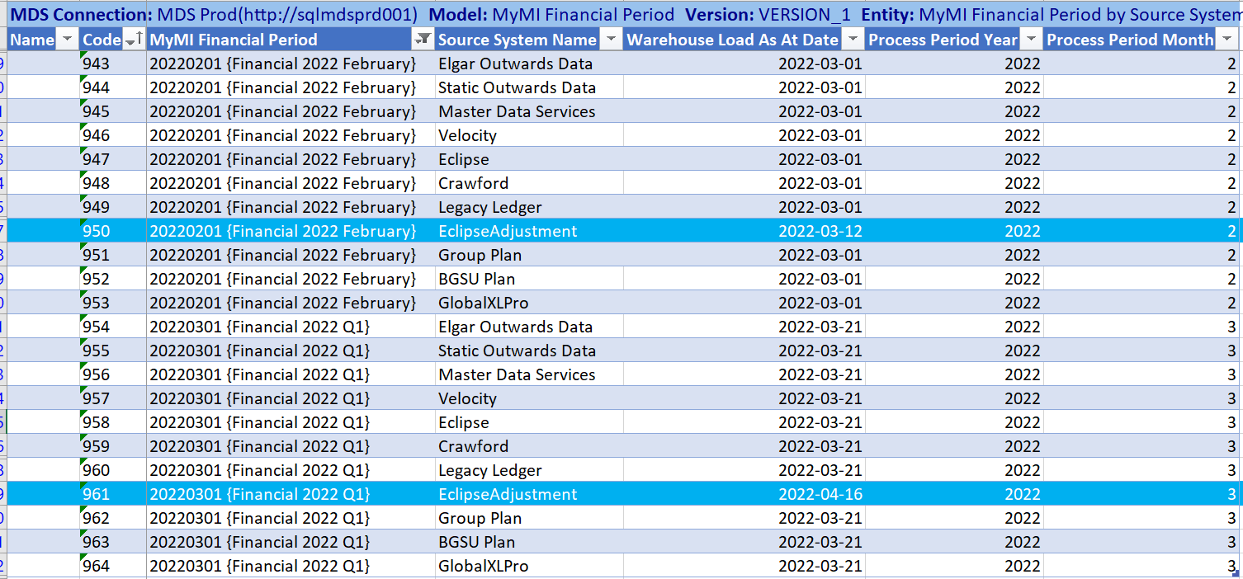

**Calendar Partition**:

Includes all transactions in Source system

+ Includes Permanent Financial Adjustments.

+ Includes Permanent Non-Financial Adjustments

**Financial Partition:**

Includes all transactions in source system

+ Includes permanent Financial Adjustments

+ Includes permanent Non-financial Adjustments

+ Includes Temporary Adjustment {*For Riverstone data feed, Temporary adjustments are excluded*}

- Excludes Future transactions

**Current Quarter End Reconciliation Process for Riverstone**

1. The Reinsurance team provides Boudreaux (BDX) data one month in advance i.e., March close data is provided using Feb financial partition of MYMI.
2. The Riverstone Team processes the calendar partition data from data feed and removes the future transactions (i.e., all transactions with process period post Feb 2022 for Feb Month close) to reconcile to BDX provided by Brit’s Reinsurance team.

**Decisions**

1. Quarter End Reconciliation Process: There is ***no*** special provision for Riverstone quarter end close process. The BDX and close process would be validated in UAT by Reinsurance and Riverstone team. The temporary adjustments would be highlighted in the BDX separately.

3. The feed would be triggered weekly including both outward and inward data.

*Outward Data*:  We would provide data from the financial partition in the weekly feed. Benefit: There would be no need to remove future transactions for the month close reconciliation process.

*Inward Data*: We would continue to provide data from MYMI Calendar partition in the weekly feed. (Includes future transactions too).

4. Day for Load: Riverstone team are reviewing the day for the Load (TBD). As per BAU support team, Brit’s preferred days are Monday to Thursday. The support team would be available to review and manage any issues during the load and after the completion of reconciliation process in Data access layer.

## MYMI Indicator for Robin Inward and Outward Transaction

|  |  |
| --- | --- |
| Proposed | Phase II |
| User Story | MYMI Changes: In MYMI, there should be a Robin transaction indicator for Inward and Outward Transaction like Legatum. |
| Deliverables | * For Inward: A new BNB switch would be introduced called “RITC Robin” for Robin transaction. * For Outward: There would be a new flag “RITC Robin” to identify ORI Transaction for RITC Robin. * This change would be implemented in MYMI. |
| Acceptance Criteria | *Inward Transactions Flag: Bureau Non-Bureau (BNB) Switch*   1. The BNB switch is used to flag inward transactions for RITC Robin or RITC Legatum. 2. The Legatum BNB Flag would be renamed as “RITC Legatum” and new flag “RITC Robin” would be added with the rules defined for YOA, Syndicate and Group Class. (Please refer to Robin Config rules table below.) 3. The number of transactions routing to “RITC Legatum” and “Legatum” BNB switch should remain unchanged. 4. In MYMI SQL Layer, the RITC Robin criteria would be applied as captured below with exception to Group Class “Engineering & CPE”. This class would have 2988 and 2987 syndicate routing to RITC Robin. In Eclipse & Group Cube, however, the RITC Robin would match the below mentioned criteria as a scope change would be implemented in the cubes. 5. The data feed would take transactions with BNB switches prefixed as “RITC”. For Robin RITC, additional check would be applied in the data feed to include only Syndicate:2987 transactions.   *Outward Transactions Flag: ORI Legatum Flag*   1. The ORI Legatum flag would apply to only outward transactions. ORI Legatum table would have three values: “Retained {0}, “RITC Legatum {2}”, “RITC Robin {4}”. A transaction would be flagged as only one ORI Legatum flag. 2. The Robin flag would be set using YOA, External syndicate, Excluded Contract Ref and Group Class. 3. The ORI Legatum flag definition is changed to include the new contract exclusion rule, so the number of transactions flagged as “RITC Legatum” in TEST/DEV would be less than number of transactions flagged as “Legatum” in PROD. 4. All historical MYMI unadjusted ORI transactions should be data fixed to set the Robin and Legatum flags. 5. The historical partition, if rebuilt, would show the ORI data with new definitions for unadjusted data only. 6. The MYMI ORI Adjusted transactions should not be data fixed for Robin and Legatum flag, hence the historical partitions, if rebuilt, should show same data as PROD. 7. The data feed would take MYMI ORI transactions with ORI Legatum Flag is not equal “Retained”. 8. The MYMI ORI transactions which are flagged as “RITC Legatum” or “RITC Robin” would contain temporary adjustments for future partitions only. The data feed procedure would filter out temporary adjustments.   The detailed requirements are covered in the section below. |
| Testing Approach | At least two weekly Inward data and two monthly outward close data should be reviewed to validate the flags. |
| Status | Approved |
| Additional Details | Existing Adjustments for Robin and Legatum Class: |

## Exclude ORI Contract Ref from Outward Fact

|  |  |
| --- | --- |
| Proposed | Phase II |
| User Story | MYMI Changes: The ORI Outward flag should be modified to exclude RITC Contract references. |
| Deliverables | 1. This information should be implemented in MDS so that the change can be scaled to other future RITC agreements. 2. This change would be implemented in MDS and MYMI. |
| Acceptance Criteria | 1. For Legatum agreement: LEGATUM2018 should be excluded and LEGATUM2018ADJ should be included. 2. For Robin agreement: The contracts to exclude for Project Robin are ROBIN2021 and ROBIN2021C 3. The change would be applied for historical period via a data fix for unadjusted transactions only. 4. The MYMI Outward transactions for the excluded contract should not be flagged as “Retained”. |
| Testing Approach | This user story can be tested in one data feed. |
| Status | Approved |

**Definition of Legatum Flag**

The Legatum RITC requires all transaction with matching Group Class falling between the start YOA and end YOA, any external syndicate with process period on and after 201811 to be transferred to Riverstone. The ORI Legatum Flag definition is changed to due to exclusion of ORI Contract: Legatum2018. The Inward BNB Switch “Legatum” definition remains unchanged.

|  |  |  |  |  |  |
| --- | --- | --- | --- | --- | --- |
| Name | Start YOA | End YOA | External Syndicate | Opening Periods | New Rule ORI data: Exclude Contract Ref |
| AVIATION BY | 2002 | 2014 | Any (*) | Starting from 201811 | LEGATUM2018 |
| DISC 2400 | 1993 | 2014 | Any (*) |
| DISC 800 | 1993 | 2001 | Any (*) |
| DISC UK | 2002 | 2014 | Any (*) |
| PI NON-US | 2002 | 2017 | Any (*) |
| EL UK | 2002 | 2014 | Any (*) |
| PL INT | 2004 | 2004 | Any (*) |
| PL UK | 2002 | 2014 | Any (*) |
| DISC 735 | 1993 | 2001 | Any (*) |
| DISC 250 | 1993 | 2001 | Any (*) |
| DISC 1202 | 1993 | 2001 | Any (*) |
| DISC 2040 | 1993 | 2014 | Any (*) |

*Table 1: Legatum Config rules*

**Definition of Robin Flag**

Similarly for Robin RITC the transaction selection criteria are as shown below:

|  |  |  |  |  |  |
| --- | --- | --- | --- | --- | --- |
| GROUP CLASS | START YEAR | END YEAR | External  Syndicate for Outward/Syndicate for Gross Tx | Process Period | ORI data: Exclude Contract Ref |
| BGSU CASUALTY RI LATAM | 2002 | 2020 | 2987 | Post  Sep 2021 Financial Close | ROBIN2021 and ROBIN2021C |
| BGSU ENGINEERING FAC LATAM | 2002 | 2020 | 2987 |
| BGSU INLAND MARINE | 2002 | 2020 | 2987 |
| BGSU LIABILITY ARP SC | 2002 | 2020 | 2987 |
| BGSU LIABILITY PACKAGE CJSO | 2002 | 2020 | 2987 |
| BGSU LIABILITY PACKAGE FD | 2002 | 2020 | 2987 |
| BGSU PROPERTY FAC LATAM | 2002 | 2020 | 2987 |
| BGSU PROPERTY PACKAGE CJSO | 2002 | 2020 | 2987 |
| BGSU PROPERTY PACKAGE FD | 2002 | 2020 | 2987 |
| BGSU PROGRAMS | 2002 | 2020 | 2987 |
| BGS SINGAPORE | 2002 | 2020 | 2987 |
| CHINA CONSTRUCTION | 2002 | 2020 | 2987 |
| ENGINEERING & CPE | 2002 | 2020 | 2987 |
| AEROSPACE LIABILITY | 2002 | 2020 | 2987 |
| AIRLINES HULL | 2002 | 2020 | 2987 |
| AIRLINES LIABILITY | 2002 | 2020 | 2987 |
| AVIATION XL | 2002 | 2020 | 2987 |
| GENERAL AVIATION HULL | 2002 | 2020 | 2987 |
| GENERAL AVIATION LIABILITY | 2002 | 2020 | 2987 |
| SCION CASUALTY | 2002 | 2020 | 2987 |
| BGSU LIABILITY PACKAGE SIR | 2002 | 2018 |  |
| BGSU PROPERTY PACKAGE SIR | 2002 | 2018 |  |

*Table 2: Robin Config. rules*

**Decisions**

1. In Data Lake, only the group class, External syndicate, Excluded Contract ref (only for ORI) and YOA matching would be applied. The process period matching would be excluded and would be managed by on Riverstone side for ORI and inward datasets.

**2. Outward Reinsurance Data:**

Unadjusted Transactions:

*Current Process Period:* The above config rules would be used to set Legatum and Robin Flag.

*Historical Process Period:* As in MYMI the outward data for the historical process periods are locked after the month is closed, the historical process period would be data fixed to set the Robin and Legatum flag (as per new definitions). There is no requirement to rebuild existing SQL and Cube partitions but as the curated layer has changed for historical process periods for old partitions, if the new snapshot layer and SQL layer are rebuilt, the data in all layers post curated layer would change.

Adjusted Transaction: We found ORI adjustments for Robin classes in process period 202210; however, it is agreed that adjustments should be flagged as Robin/Legatum (for new definition) only on going forward basis and no data fix required for historical partitions.

**3. Inward Data:**

Unadjusted Transaction: The BNB flag sets the flag for all process periods on going forward basis, so the change would affect only the future MYMI partitions.

Adjusted Transactions: In line with ORI adjustments, Eclipse adjustments should be flagged as Robin only on going forward basis.

**4. Master & Declaration data for Robin Transaction:** The RITC Robin transactions have binders and declaration data unlike RITC Legatum transactions. The data feed is designed to read master data as agreed with Riverstone team.

**5. Robin Selection Criteria:** The selection criteria for RITC Robin are defined at Policy line level unlike RITC Legatum Transactions where the policy selection criteria are defined at policy level. It was identified that for Group Class “Engineering & CPE” has policies with lines for 2988 and 2987, which meant that only one policy line i.e., 2987 should be flagged for RITC Robin. The BNB flag currently works at Policy level and would require a design change to apply BNB flag Policy line level. It was agreed that the change of granularity would be descoped for the project.

Tactical Solution: In Riverstone data feed (i.e., MYMI Procedures), additional rule would be applied to only include syndicate 2987 in the MYMI procedures. In Cube, the scope change would be implemented to hide 2988 transaction.

# Annexure

## BA Testing Strategy

***MYMI Changes:***

* Change of BNB Legatum to RITC Legatum- Unadjusted Data: Compare RITC Legatum DEV/TEST to Legatum PROD
* Change of BNB Legatum to RITC Legatum- adjusted Data: New Adjustment applied, and they should be flagged as Legatum RITC
* "Add New switch for RITC Robin - Unadjusted Data:
  + Compare Robin Switch in DEV to Financial Reporting/Non-Bureau switch in DEV
  + Regression: All other Switch in DEV to All other Switch in PROD"
* Add New switch for RITC Robin Existing Adjustment in Current Partition
* Add New switch for RITC Robin :Add new adjustment on Robin classes
* ORI Legatum Data Fix- Unadjusted Data Flag Verification
* ORI Legatum - adjusted Data: No Change, only going forward basis
* ORI Robin Data Fix: Unadjusted Data Flag Verification
* Change tracking: ORI Robin Data Fix/ORI Legatum: Unadjusted Data
* Rebuild old Partition: ORI Robin Data Fix/ORI Legatum: Unadjusted Data
* ORI Legatum - adjusted Data: No Change, only going forward basis
* Add ORI Adjustment on Robin and Legatum Classes.
* "Impact on Reports and Extracts:
  + BGS Direct MI Pack.rdl
  + Premium Income Monitoring Sub Detail.rdl
  + ClassSum_AAMExtract.rdl
  + ClassSum_Extract.rdl
  + Premium and Earnings Report.rdl
  + Triangulation Detail Report.rdl
  + Triangulation Summary Report.rdl"

***Riverstone Extract***

* Inward Schema Check
* Inward AS-AT Data testing
* Inward Excluding Temporary Adjustment data testing
* Outward Schema Check
* Outward Data Testing with granularity check
* Frequency Check
* Achieving Check
* Reconciliation Check
* Recheck all after MYMI testing is complete

## Legatum Feed Specification



## High level Requirements V 0.5



## Technical Solution Specification



## Impact Assessment Document

